**NAME**: RUDRA SNEHA

**PROJECT TITLE**: A CRM APPLICATION FOR LAPTOP RENTALS

**MAIL ID**: [rsneha_cse2105b7@mgit.ac.in](mailto:rsneha_cse2105b7@mgit.ac.in) **COLLEGE NAME**: MAHATMA GANDHI INSTITUTE OF TECHNOLOGY

**A CRM APPLICATION FOR LAPTOP RENTALS**

# Project Overview

This project is focused on **Salesforce Implementation for Laptop Rentals**, designed to streamline the management of laptop bookings, consumer details, and inventory (Total Laptops). The goal is to deliver a comprehensive solution by leveraging Salesforce's

custom objects, automation flows, and Apex triggers. Through this project, we aim to enhance **operational eﬃciency, customer experience, and data management** while

supporting the long-term goals of **improving business operations and customer satisfaction** in laptop rental services.

# Objectives

### Business Goals:

* + - Efficient management of laptop inventory and booking process.
    - Automate the workflow for laptop rentals based on customer preferences.
    - Ensure accurate billing and availability status of laptops.

### Specific Outcomes:

* + - Custom Salesforce objects for **Laptop Bookings**, **Total Laptops**, **Consumers**, and

### Billing Process.

* + - Automated notifications and workflows for laptop booking confirmations.
    - Reports to analyze laptop booking trends and consumer details.

# Salesforce Key Features and Concepts Utilized

* + **Custom Objects**: Total Laptops, Consumers, Laptop Bookings, Billing Process.
  + **Fields & Relationships**: Custom fields like phone numbers, email, laptop status, and relationships between objects.
  + **Validation Rules**: Ensures fields like phone numbers and emails are not blank in the Consumer object.
  + **Profiles & Roles**: Custom roles for **Owner** and **Agent**, with specific permissions for each.
  + **Flow**: Record-triggered flows to automate laptop rental calculations based on selected criteria (e.g., Dell, Acer,Hp,Mac).
  + **Apex Trigger & Handler Class**: Trigger for sending email notifications after laptop booking, including details like laptop type and core type.
  + **Reports**: Reports that display laptop booking information across various consumer and laptop booking objects.

# Detailed Steps to Solution Design

## Custom Objects Creation:

* + Total Laptops, Consumer, Laptop Bookings, and Billing Process objects were created with necessary fields such as:
    - Laptop Name, Consumer Phone, Email, Status, Amount, Core Type, etc.

## Validation Rule:

* + Created a validation rule to ensure that the phone number and email fields are not left blank in the **Consumer** object.
    - Formula: OR(ISBLANK(phone_number_c), ISBLANK(email_c))

## Profiles and Roles:

### Owner Profile:

* + - Cloned from Standard User profile, with permissions for the custom objects.

### Agent Profile:

* + - Cloned from Standard Platform User profile, with permissions for Laptop Bookings and Consumer objects.

## Flow:

* + A **Record-Triggered Flow** was designed to automate the amount calculation for different laptop types (Dell, Acer, HP) based on selected months and core types (e.g., Core i3, Core i5, Core i7).
    - **Decision elements** were used to handle different outcomes based on laptop type and core type.

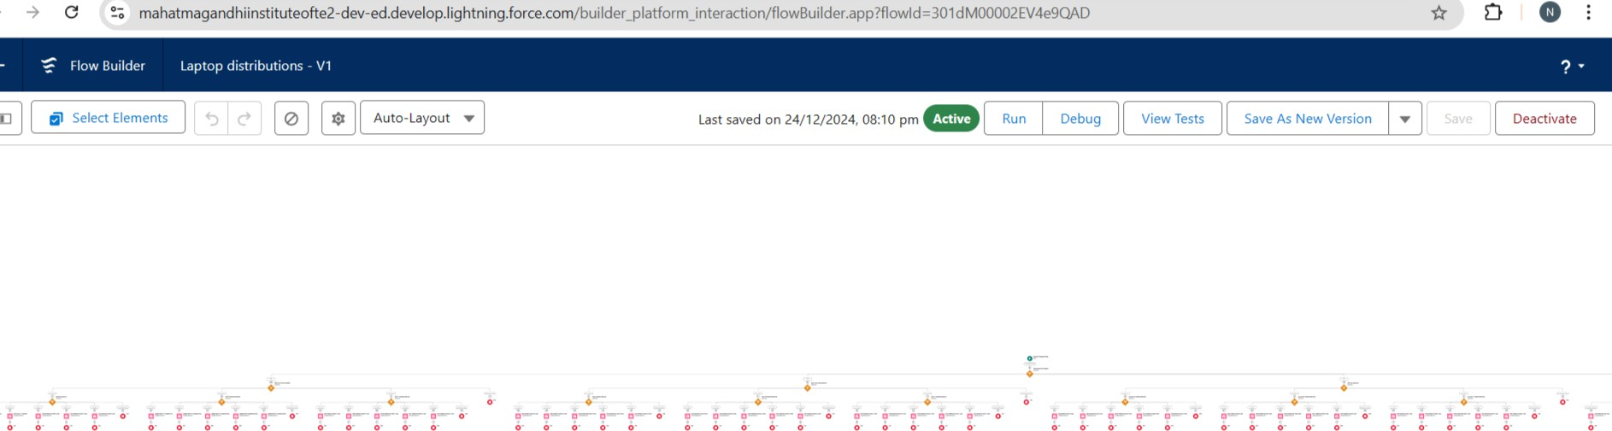

## Apex Trigger & Handler Class:

* + **Trigger**: LaptopBooking to handle after insert or update events.
    - Calls the **LaptopBookingHandler** class to send email notifications.
  + **Handler Class**: Sends a personalized email to consumers after booking, including details like laptop name, core type, and rental amount.

# Testing and Validation

## Unit Testing:

* + Test the Apex Trigger and Handler Class to ensure that emails are sent after a new booking or update.

## User Interface Testing:

* + Verify that the custom fields, validation rules, and flows function as expected for the end users.

## Validation Rule Testing:

* + Ensure that users cannot create or update consumer records with missing phone numbers or emails.

# Key Scenarios Addressed by Salesforce in the Implementation Project

* + **Laptop Availability Calculation**: When a laptop is booked, the "Laptops Available" field is updated automatically using the formula 50 - Laptops_delivered c.
  + **Email Notifications**: After booking, an email is sent to the consumer with booking

details.

* + **Conditional Updates**: The flow updates the rental amount based on laptop type (Dell, Acer) and core type (Core i3, i5, i7).
  + **Reports**: The system generates reports showing laptop booking trends, consumer data, and availability.

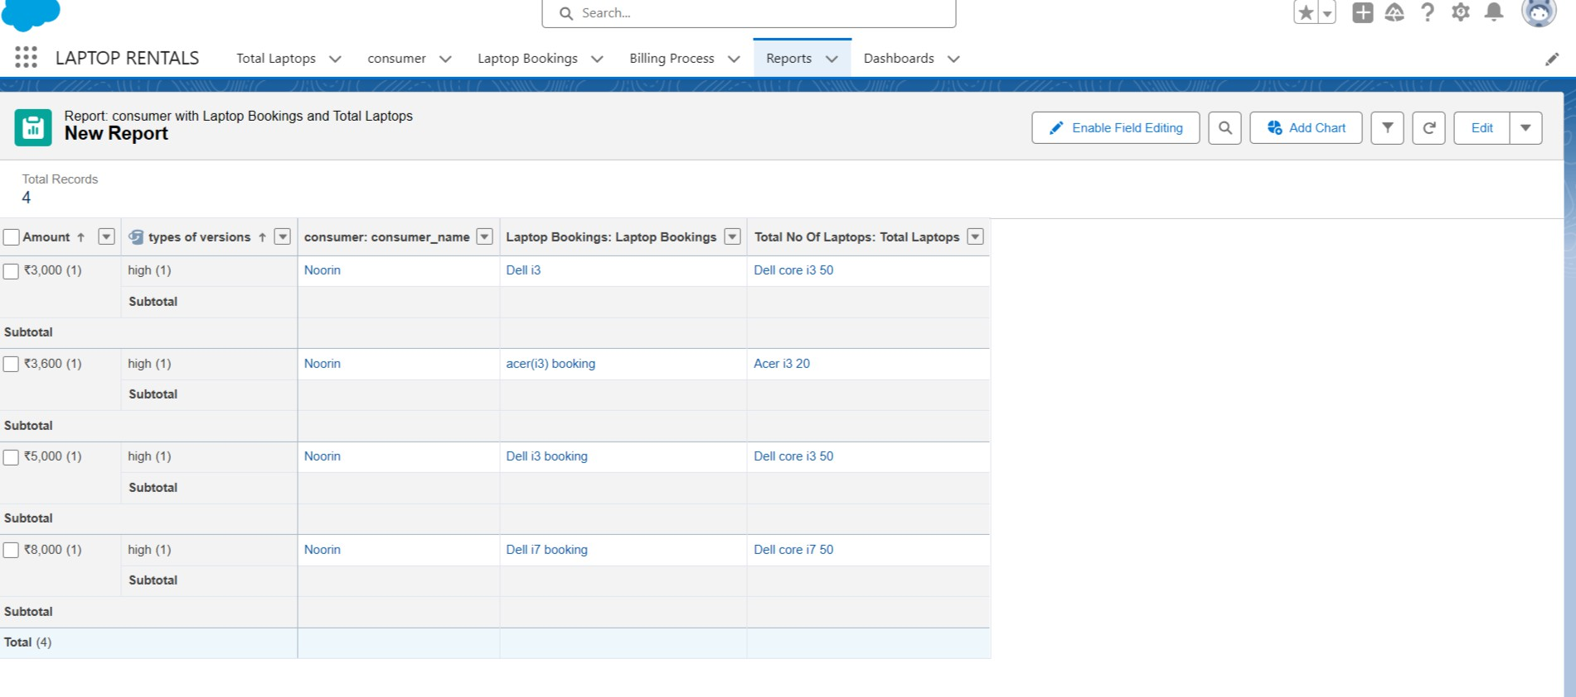

* + **Dashboard:**

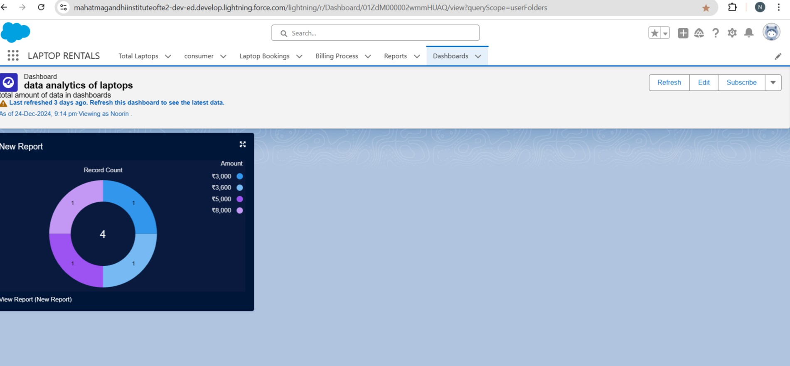

# Conclusion

Through the implementation of custom Salesforce objects, automation with flows, and Apex triggers, this project successfully streamlined the laptop booking process, enhanced customer interaction with automated email notifications, and improved data management for laptop rentals. The use of reports and validation rules ensures better data accuracy and operational efficiency.